

Artificial Intelligence Lab

Lab 03

SUBMITTED BY: Muneeb ur Rehman
SUBMITTED TO: Ma’am Hajra
REGISTRATION NO: 232101003
SEMESTER: BSCE-VII
DATE: 25th sep, 2026

DEPARTMENT OF COMPUTER ENGINEERING
INSTITUTE OF SPACE TECHNOLOGY ISLAMABAD

KICSIT, KAHUTA CAMPUS
Question 1
Practice numerical computing and data manipulation using NumPy, Pandas, and Matplotlib and Execute a data analysis workflow using the Iris Dataset. Load the dataset using Pandas, perform numerical analysis using NumPy, and generate appropriate visualizations using Matplotlib to investigate the relationships among sepal length, sepal width, petal length, and petal width. Analyze the statistical results and visualizations to identify meaningful patterns, distributions, and relationships among different Iris flower classes. Evaluate how Python-based data analysis can support the identification of suitable features and prepare a dataset for Machine Learning applications.
This activity develops specialist AI knowledge (WK4) and engineering practice knowledge (WK6) by applying Python-based data analysis techniques to an AI dataset. It develops EC1 (Comprehend and apply universal knowledge) and EC3 (Problem Analysis) through numerical analysis, data manipulation, and interpretation. The activity supports PLO-02 (Problem Analysis) and PLO-05 (Modern Tool Usage) and contributes to SDG 9 (Industry, Innovation and Infrastructure) through the application of modern data-analysis technologies.
Task Requirements
- Load the Iris Dataset using Pandas.
- Identify and document:
- Number of records and features
- Feature names
- Data types
- Target/class variable
- Basic statistical information
- Use NumPy to calculate statistical measures such as:
- Mean
- Minimum
- Maximum
- Standard deviation
- Use Pandas to perform data manipulation, including:
- Selecting relevant columns
- Filtering records
- Grouping data according to Iris flower class
- Calculating summary statistics
- Use Matplotlib to generate at least three visualizations to investigate the dataset.
- Analyze the generated results and identify at least two meaningful patterns or relationships among the Iris flower features and classes.
- Based on the analysis, identify which features appear useful for distinguishing different Iris flower classes and explain how the analyzed data can be used as a foundation for Machine Learning.
[CLO- 01, PLO-02, P3 (Practice), WK4, EC1, EC2 and SDG 9 Rubric (Design, (Outcome) Points (12)]
Solution:

Data Analysis Using NumPy, Pandas and Matplotlib

Objective
The objective of this activity is to perform numerical computing and data analysis using Python libraries NumPy, Pandas, and Matplotlib. The Iris dataset is analyzed to understand its features, statistical properties, class distributions, and relationships among different measurements. The analysis also helps identify useful features that can be used as a foundation for Machine Learning applications.

1. Dataset Loading and Overview
The Iris dataset was loaded using Python and converted into a Pandas DataFrame. The dataset contains 150 records and 4 numerical features, with an additional class column representing the Iris species.
The four features are:
- Sepal Length
- Sepal Width
- Petal Length
- Petal Width
The target/class variable contains three Iris species:
- Setosa
- Versicolor
- Virginica
The numerical features have floating-point data types, while the class variable contains categorical values.

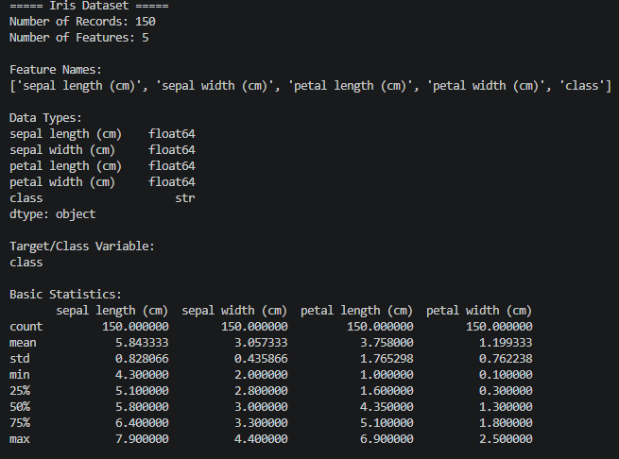

2. Basic Statistical Analysis Using NumPy
NumPy was used to calculate the mean, minimum, maximum, and standard deviation of each numerical feature.
The analysis provides information about the central tendency and variation of the Iris measurements. These statistical values help in understanding the range and distribution of the dataset before applying Machine Learning techniques.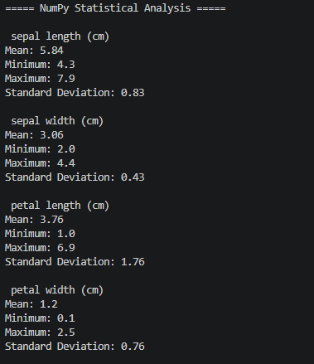

3. Data Manipulation Using Pandas
Pandas was used to perform different data manipulation operations. Relevant columns were selected, records were filtered based on petal length, and the dataset was grouped according to Iris species.
The average measurements for each Iris class were also calculated. The class counts were examined to understand the distribution of records among the three species.
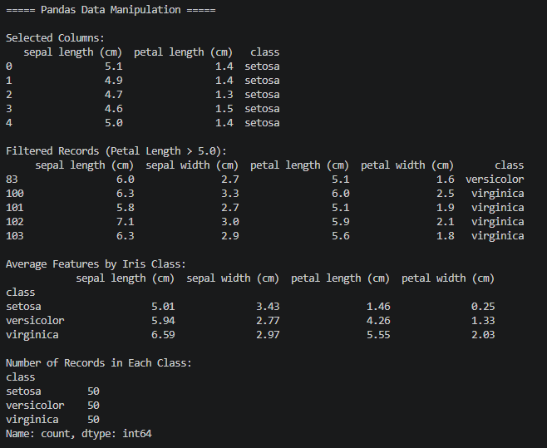

4. Data Visualization
Matplotlib and Seaborn were used to visualize relationships and distributions within the Iris dataset.

4.1 Sepal Length vs Sepal Width
The scatter plot shows the relationship between sepal length and sepal width for the three Iris species. The classes show some overlap in their sepal measurements.
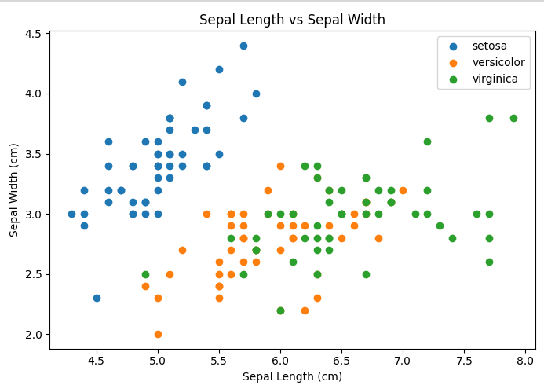

4.2 Petal Length vs Petal Width
The scatter plot shows a clearer separation among the Iris species. Petal length and petal width provide stronger visual differences between the classes.
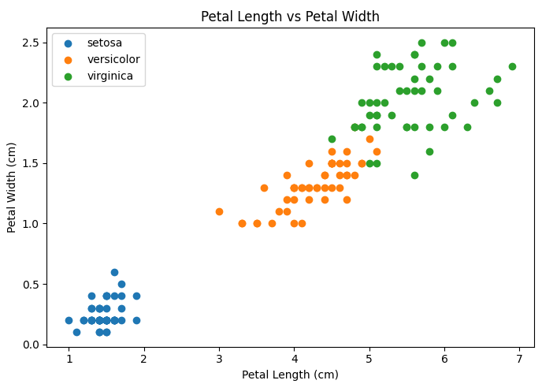

4.3 Average Petal Length by Iris Class
The bar chart compares the average petal length of the three Iris species. The average petal length differs considerably between the classes.
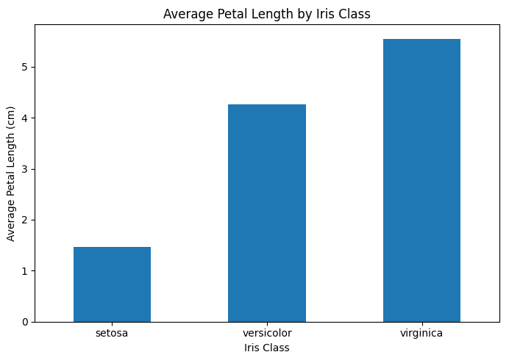

4.4 Pair Plot of Iris Features by Species
The pair plot displays relationships between the numerical features and shows how the different species are distributed across feature combinations.
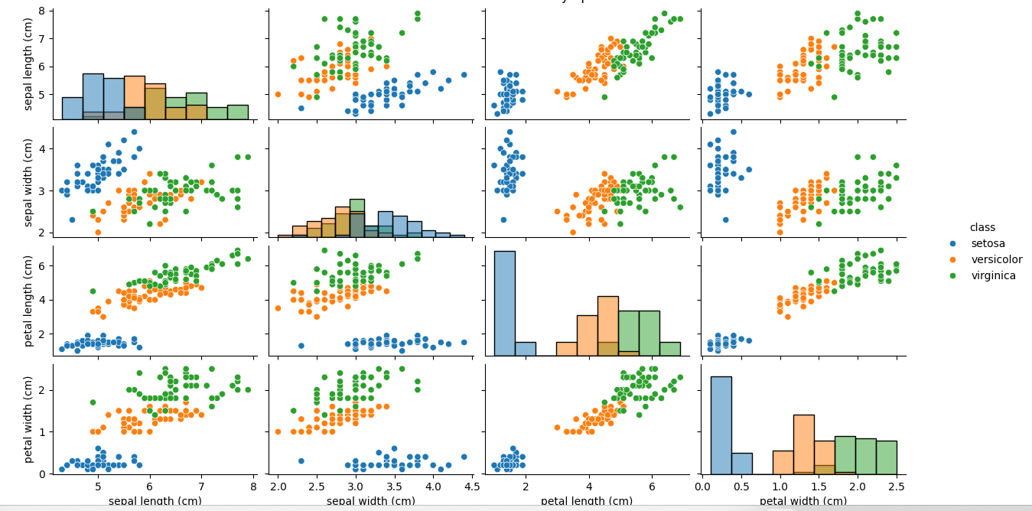

4.5 Distribution of Petal Width by Species
The distribution plot shows the variation of petal width within each Iris species. The species have noticeably different petal-width distributions.
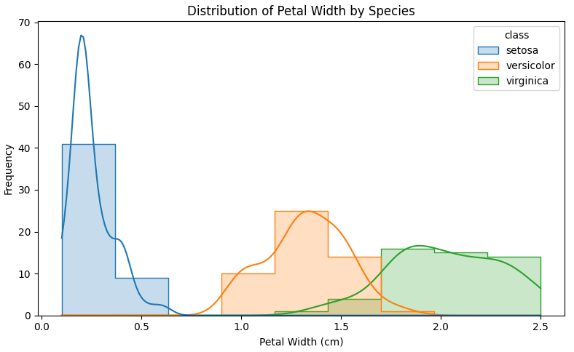

4.6 Distribution of Sepal Length by Iris Species
The distribution of sepal length shows greater overlap between species compared with the petal measurements.
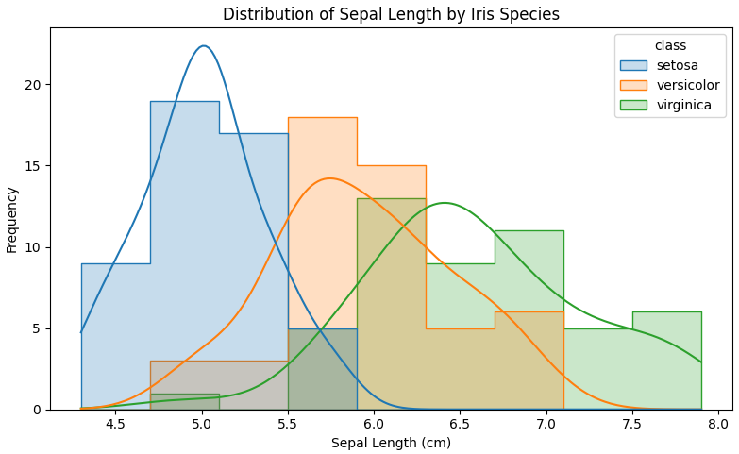

5. Machine Learning Classification Visualization
The dataset was divided into training and testing subsets. A Random Forest classifier was trained using the four numerical features. The predictions were then evaluated using a confusion matrix.

5.1 Random Forest Confusion Matrix
The confusion matrix shows the number of correctly and incorrectly classified samples for each Iris species.
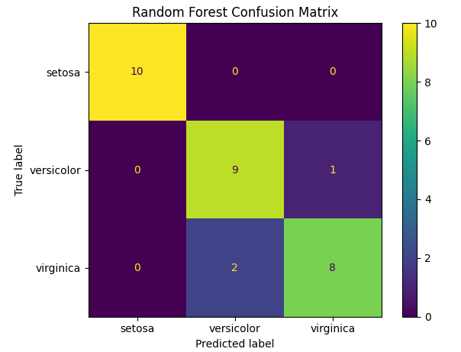

5.2 Confusion Matrix
The confusion matrix provides a visual representation of the classification results and helps identify whether samples from different Iris classes were correctly distinguished.
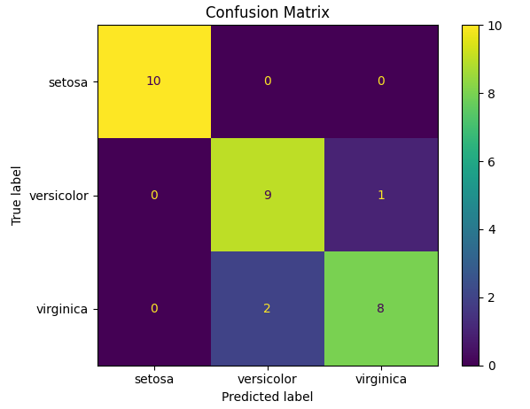

6. Analysis of Results
The statistical results and visualizations reveal several meaningful patterns.

Pattern 1: Petal Features Show Strong Class Separation
Petal length and petal width show clear differences among the three Iris species. Setosa has considerably smaller petal measurements, while Virginica generally has the largest measurements. This makes petal features useful for distinguishing between classes.

Pattern 2: Sepal Features Have More Overlap
Sepal length and sepal width show more overlap between different Iris classes. Therefore, they provide less obvious class separation compared with petal measurements.

Pattern 3: Relationship Between Petal Features
Petal length and petal width show a clear relationship across the Iris samples. Their combination provides useful information for separating the different species.

7. Useful Features for Machine Learning
Based on the statistical analysis and visualizations, the following features can be considered useful for Machine Learning:
- Petal Length
- Petal Width
- Sepal Length
- Sepal Width
Among these, petal length and petal width show stronger class separation in the analyzed visualizations.
The analysis demonstrates how exploratory data analysis can help identify informative features before training a Machine Learning model. It also helps understand data distributions, relationships, and possible class separation.

8. Conclusion
The Iris dataset was successfully analyzed using NumPy, Pandas, Matplotlib, and Seaborn. NumPy was used for numerical statistical analysis, Pandas was used for data selection, filtering, grouping, and summary statistics, while visualization libraries were used to investigate relationships and distributions.
The analysis showed that petal length and petal width provide clear differences among Iris species, while sepal measurements have greater overlap. A Random Forest classifier was also used to visualize classification results through a confusion matrix.
Overall, Python-based data analysis provides an effective foundation for preparing datasets, selecting useful features, understanding patterns, and applying Machine Learning techniques.

Question 2
Execute a basic Machine Learning data analysis workflow using the same Iris Dataset analyzed in Question 1 to explore the concepts of Supervised and Unsupervised Learning. Use the features, statistical results, and visualizations obtained in Question 1 to identify the input features and target variable and determine how the dataset can be applied to a Supervised Learning problem. Further, analyze the same feature data without using the target labels to explore possible natural groups or patterns representing an Unsupervised Learning problem. Analyze the relationship between the findings from Question 1 and the selection of an appropriate learning approach. Evaluate the differences between Supervised and Unsupervised Learning and explain their suitability for different real-world AI applications.
This activity builds on the data analysis performed in Question 1 and develops Machine Learning knowledge (WK4, WK6) through the application of modern Python tools to the same dataset. It develops EC3 (Problem Analysis) by investigating the dataset and EC4 (Design and Development of Solutions) by selecting an appropriate Machine Learning approach. The activity supports PLO-02 (Problem Analysis) and PLO-03 (Design/Development of Solutions) and contributes to SDG 9 (Industry, Innovation and Infrastructure) through the application of AI and data-driven technologies.
Task Requirements
- Use the Iris Dataset and the analysis performed in Question 1 as the basis for this task.
- Identify:
- Input features
- Target variable
- Type of Machine Learning problem
- Expected output
- Execute the identification of a Supervised Learning problem using the Iris flower class as the target variable and explain how the features analyzed in Question 1 can be used for classification.
- Execute an Unsupervised Learning data exploration by using the same numerical features without using the target/class labels to investigate possible natural groups or patterns.
- Use the visualizations/results from Question 1 to compare the feature patterns observed with the possible groups identified through the Unsupervised Learning approach.
- Analyze at least two differences between Supervised and Unsupervised Learning in terms of:
- Target variable
- Learning objective
- Expected output
- Use of labelled/unlabelled data
- Give at least two real-world applications of each learning approach and relate them to the type of problem they solve.
- Evaluate why the choice between Supervised and Unsupervised Learning depends on the availability of labelled data and the objective of the AI application.
[CLO- 02, PLO-03, P4 (Execute) (WK5, EC4, and SDG 11) Rubric (Syntax, Logic, Completeness, (Outcome) Points (12)]
Solution:

Supervised and Unsupervised Learning Using Iris Dataset

Objective
The objective of this activity is to explore Supervised and Unsupervised Machine Learning using the Iris Dataset analyzed in Question 1. The input features, target variable, and suitable learning approaches are identified. Random Forest Classification is used for supervised learning, while K-Means Clustering is used for unsupervised learning.

1. Dataset and Problem Identification
The Iris Dataset contains 150 flower samples with four numerical input features:
- Sepal Length
- Sepal Width
- Petal Length
- Petal Width
The target variable is the Iris flower class: setosa, versicolor, and virginica.
Since the target classes are already known, predicting the flower class from the four features is a Supervised Learning – Classification problem.
Expected Output: The predicted class of an Iris flower based on its measured features.
For Unsupervised Learning, the same four numerical features are used without the class labels. The objective is to discover possible natural groups or patterns within the data.
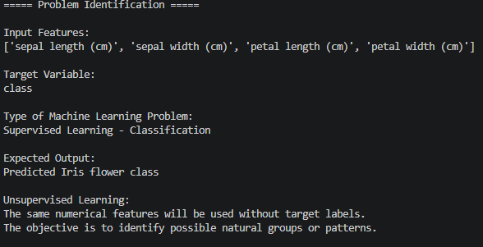

2. Supervised Learning
A Random Forest Classifier was applied to the Iris Dataset. The data was divided into 80% training data and 20% testing data.
The model used:
- Algorithm: Random Forest Classifier
- Training samples: 120
- Testing samples: 30
- Accuracy: 90%
The results show that the model can use the four flower measurements to predict the Iris species. The findings from Question 1 also showed that petal length and petal width provide clearer separation between the Iris classes.
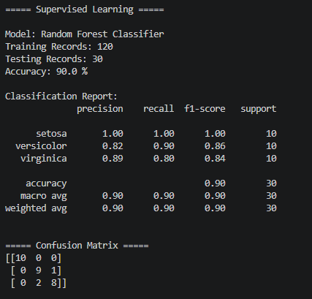

Confusion Matrix
The confusion matrix shows the actual and predicted classes of the test samples.
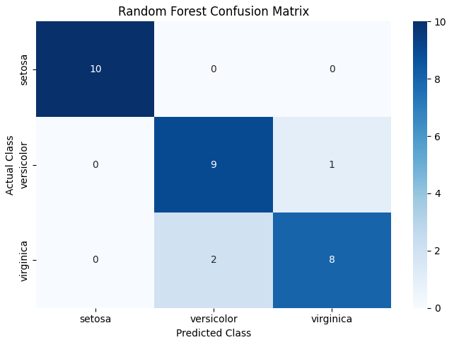
Figure 1: Random Forest Confusion Matrix
The confusion matrix indicates that most samples were correctly classified. The setosa class was separated clearly, while some confusion occurred between versicolor and virginica.

3. Unsupervised Learning
For Unsupervised Learning, the class labels were removed and only the four numerical features were used.
K-Means Clustering was applied with 3 clusters. The features were standardized before clustering so that differences in feature scales would not affect the clustering process.
The resulting clusters contained:
- Cluster 0: 53 samples
- Cluster 1: 50 samples
- Cluster 2: 47 samples
The clustering process attempts to identify groups based only on similarities in the feature values.
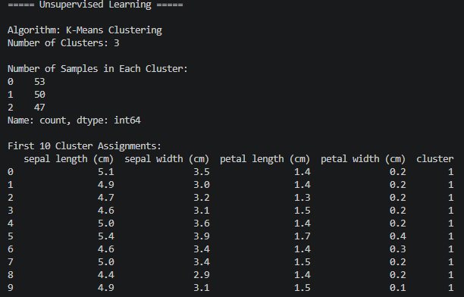

K-Means Visualization
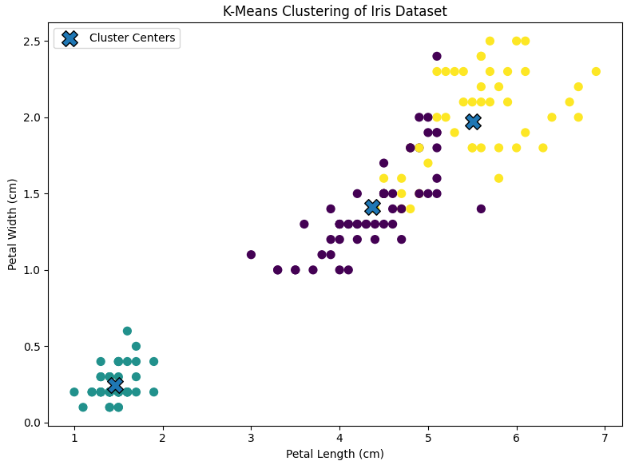
Figure 2: K-Means Clustering of Iris Dataset
The visualization shows that the numerical feature data can form distinct groups. Petal length and petal width provide noticeable separation between several groups, which is consistent with the findings obtained in Question 1.

4. Comparison with Question 1 Findings
Question 1 showed that petal length and petal width have stronger class separation than the sepal measurements. The K-Means results provide a similar observation because the feature patterns allow the algorithm to form groups without using the actual Iris class labels. This demonstrates that the patterns identified during exploratory data analysis can help in selecting an appropriate Machine Learning approach. The known class labels make classification possible in supervised learning, while removing the labels allows the same feature data to be investigated for natural groupings through unsupervised learning.
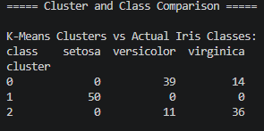

Cluster and Actual Class Comparison
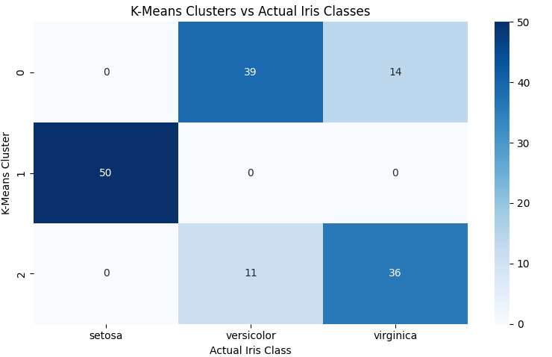
Figure 3: K-Means Clusters vs Actual Iris Classes
The comparison between clusters and actual classes helps examine how the groups discovered by K-Means correspond to the known Iris species. However, cluster numbers are generated by the algorithm and do not directly represent the original class names.

5. Supervised vs Unsupervised Learning

Aspect | Supervised Learning | Unsupervised Learning
Target Variable | Required | Not required
Data | Labelled | Unlabelled
Main Objective | Predict known outcomes | Discover hidden patterns or groups
Expected Output | Class or numerical prediction | Clusters, groups, or patterns
Iris Example | Predict Iris species | Group flowers based on feature similarity
The main difference is that supervised learning learns from known target labels, while unsupervised learning searches for patterns without predefined labels.

6. Real-World Applications

Supervised Learning
- Email Spam Detection: A model can learn from labelled emails and classify new emails as spam or legitimate.
- Medical Diagnosis: A model can use labelled patient data to predict disease categories.

Unsupervised Learning
- Customer Segmentation: Customers can be grouped according to purchasing behavior without predefined customer categories.
- Anomaly Detection: Unusual patterns in transactions or system activity can be identified by finding observations that differ from normal groups.

7. Evaluation and Selection of Learning Approach
The choice of Machine Learning approach depends mainly on the availability of labelled data and the objective of the AI application.
If labelled examples and a known target variable are available, Supervised Learning can be used to learn a relationship between input features and expected outputs. If labels are unavailable and the objective is to discover unknown structures or groups, Unsupervised Learning can be more appropriate.
In the Iris Dataset, the known flower classes make classification possible. When these labels are removed, K-Means can instead be used to explore natural groupings in the numerical feature data.

8. Conclusion
The Iris Dataset was successfully analyzed using both Supervised and Unsupervised Learning approaches. Random Forest Classification used labelled data to predict Iris flower classes and achieved 90% accuracy on the test data. K-Means Clustering used the same numerical features without class labels to identify three possible groups.
The results also supported the findings from Question 1, where petal length and petal width showed clearer patterns between Iris classes. Overall, the appropriate Machine Learning approach depends on whether labelled data is available and whether the goal is prediction or pattern discovery.

